SCHOOL

Year 12 Trial WACE Examination, 2013

Question/Answer Booklet

MATHEMATICS 3C/3D
SOLUTIONS

Section Two:

Calculator-assumed

Student Number: In figures

In words

Your name

Time allowed for this section
Reading time before commencing work: ten minutes
Working time for this section: one hundred minutes

Materials required/recommended for this section

To be provided by the supervisor
This Question/Answer Booklet
Formula Sheet (retained from Section One)

To be provided by the candidate
Standard items: pens, pencils, pencil sharpener, eraser, correction fluid/tape, ruler, highlighters

Special items: drawing instruments, templates, notes on two unfolded sheets of A4 paper, and up to three calculators satisfying the conditions set by the Curriculum Council for this examination.

Important note to candidates

No other items may be used in this section of the examination. It is your responsibility to ensure that you do not have any unauthorised notes or other items of a non-personal nature in the examination room. If you have any unauthorised material with you, hand it to the supervisor before reading any further.

Structure of this paper

Section | Number of questions available | Number of questions to be answered | Working time (minutes) | Marks available | Percentage of exam
Section One:  Calculator-free | 8 | 8 | 50 | 50 | 33
Section Two:  Calculator-assumed | 13 | 13 | 100 | 100 | 67
 |  |  | Total | 150 | 100

Instructions to candidates

- The rules for the conduct of Western Australian external examinations are detailed in the Year 12 Information Handbook 2013. Sitting this examination implies that you agree to abide by these rules.

- Write your answers in the spaces provided in this Question/Answer Booklet. Spare pages are included at the end of this booklet. They can be used for planning your responses and/or as additional space if required to continue an answer.
- Planning: If you use the spare pages for planning, indicate this clearly at the top of the page.
- Continuing an answer: If you need to use the space to continue an answer, indicate in the original answer space where the answer is continued, i.e. give the page number. Fill in the number of the question(s) that you are continuing to answer at the top of the page.

- Show all your working clearly. Your working should be in sufficient detail to allow your answers to be checked readily and for marks to be awarded for reasoning. Incorrect answers given without supporting reasoning cannot be allocated any marks. For any question or part question worth more than two marks, valid working or justification is required to receive full marks. If you repeat an answer to any question, ensure that you cancel the answer you do not wish to have marked.

- It is recommended that you do not use pencil, except in diagrams.

Section Two: Calculator-assumed (100 Marks)
This section has thirteen (13) questions. Answer all questions. Write your answers in the spaces provided.

Working time for this section is 100 minutes.

Question 9 (4 marks)
Part of the graph of 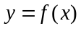 is shown below. The areas of regions A and B, bounded by the curve and the -axis, are 9 and 1 square units respectively.
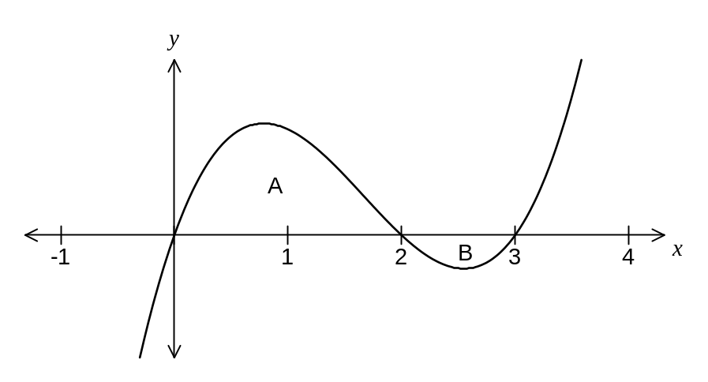
Evaluate
(a) 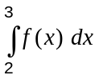 (1 mark)
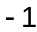

(b) 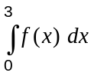 (1 mark)
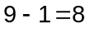

(c) 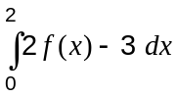 (2 marks)
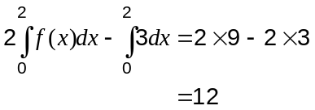

Question 10 (6 marks)
Let 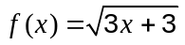 and 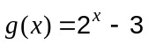.

(a) Determine a simplified expression for 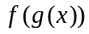 and hence state the domain of .
(3 marks)
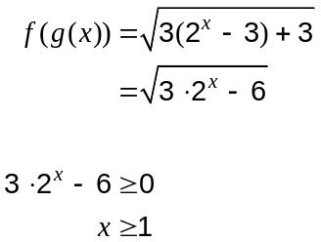

(b) Write down an expression for 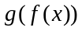 and determine the range of this composite function.
(3 marks)
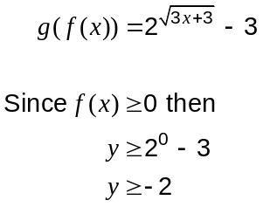

Question 11 (7 marks)
The population , in thousands, of a city was observed to grow according to the model 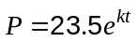, where is the time in months from January 1, 2004.

(a) What was the population of the city on January 1, 2004? (1 mark)
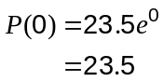
Population was 23 500.

(b) Show that this growth model satisfies the differential equation 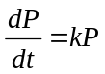. (1 mark)
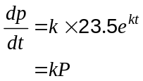

During January 2004, the population of the city increased by 56 people.

(c) Determine the value of , rounding your answer to three significant figures. (2 marks)

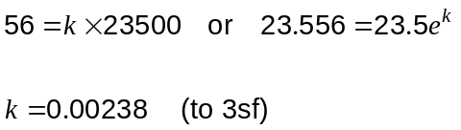

(d) According to the model, during which month of which year did the population of the city first exceed 26 thousand people? (3 marks)

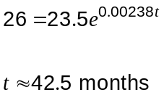

During July 2007.

Question 12 (7 marks)
A sports medical unit performs urine tests to detect the presence of a certain steroid. It is known that for 89% of samples containing the steroid, the test indicates its presence but for 2% of samples free of the steroid, the test falsely indicates its presence.

At a large event, the unit suspect that 8% of the athletes are using the steroid and plan to randomly sample urine from 25% of the athletes.

Calculate the probability that

(a) a randomly chosen athlete who does not use the steroid is selected for a urine test and the test falsely indicates its presence. (1 mark)

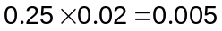

(b) the test indicates the presence of the steroid in a urine sample from a randomly chosen athlete. (3 marks)
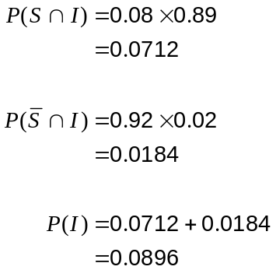

(c) the urine of a randomly chosen athlete contains the steroid, given that the test does not indicate its presence. (3 marks)

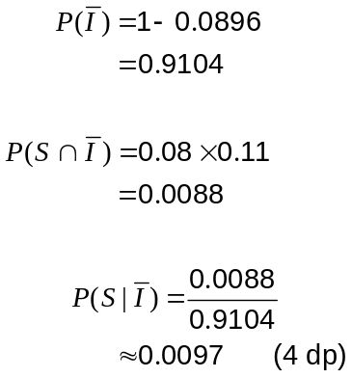

Question 13 (7 marks)
The ratio of height () : radius () for a particular cone is 2 : 3.

(a) Show that the volume of the cone is given by 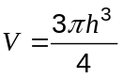. (2 marks)
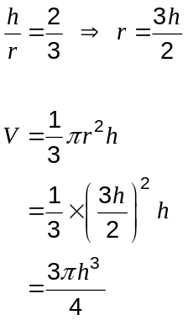

(b) An inverted cone with the above proportions is being filled with water at a rate of 200 cm³ per second. At what rate is the depth of water in the cone increasing at the time when the depth is 6 cm? (3 marks)
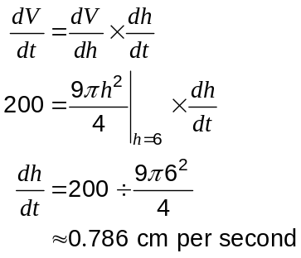

(c) Using the formula 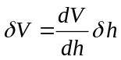, find the approximate increase in the volume of water in the cone as the depth of water increases from 6 cm to 6.05 cm. (2 marks)

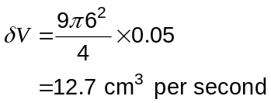

Question 14 (6 marks)
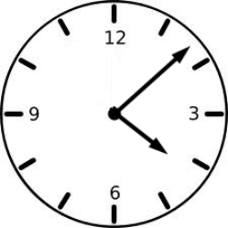
When the batteries of an analogue alarm clock fail, both hands of the clock stop in a random position.

The clockwise angle from 12 at which the hour hand stops is uniformly distributed between 0° and 360° with a mean of 180° and a standard deviation of 104°.

(a) What is the probability that the hour hand of an analogue alarm clock stops at an angle between 120° and 210°? (1 mark)

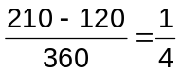

(b) Five analogue alarm clocks stop independently of each other. Determine the probability that none of their hour hands stop at an angle between 120° and 210°. (2 marks)

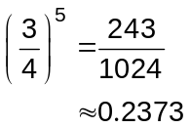

(c) 100 analogue alarm clocks stop independently of each other. Use the Central Limit Theorem to estimate the probability that the mean of the 100 angles at which the hour hands stop is less than 160°. (3 marks)
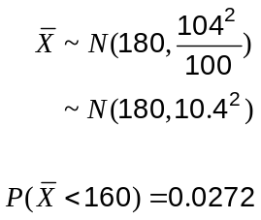

Question 15 (9 marks)
Feedback to a customer service call centre indicates that 46% of customers are currently satisfied with the response to their inquiry. The centre management want to improve this percentage and plan to replace the existing system with a new system.

Let the discrete random variable 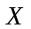 represent the number of the next 200 callers who will be satisfied with the response to their inquiry using the existing call centre system.

(a) Define the probability distribution of . (2 marks)

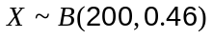

(b) Calculate the mean and standard deviation of . (2 marks)

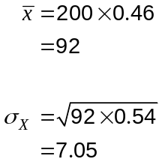

(c) What is the probability that more than half of the next 200 callers will be satisfied with the response to their inquiry using the existing call centre system? (2 marks)

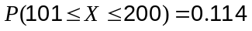

(d) After implementing the new system, customer feedback indicates that 101 out of the next 200 callers were satisfied with the response to their inquiry. Is this strong evidence that the new system is an improvement over the existing system? (3 marks)
No, there is not strong evidence of an improvement.

From (c) we know that there is an 11.4% chance that 101 or more customers will be satisfied by the existing system.

Although this does suggest an improvement, a probability of more than 1 in 10 does not count as strong evidence.

Question 16 (9 marks)
The graph of the continuous function has a local minimum at 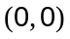, a horizontal point of inflection at 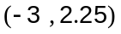 and no other stationary points.
The graph also has a point of inflection at 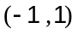.

(a) Sketch a possible graph of on the axes below. (3 marks)
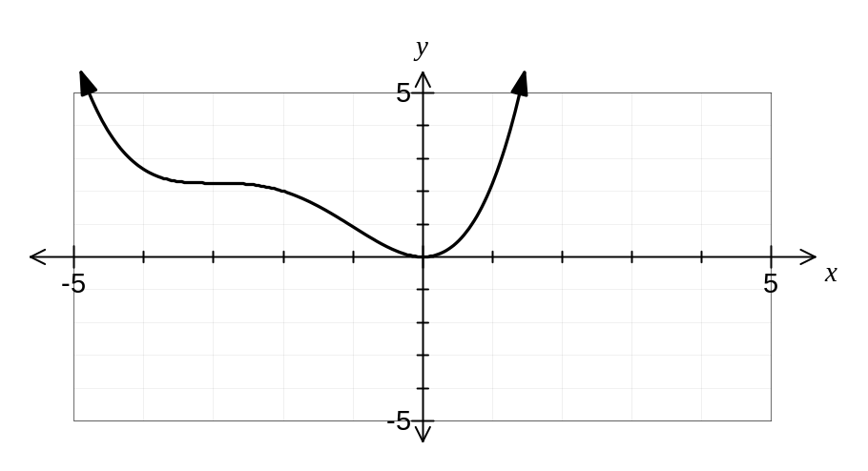

(b) Determine the coordinates of the roots of the graph of 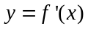. (2 marks)
At (-3, 0) and (0, 0).

(c) Sketch a possible graph of on the axes below. (2 marks)
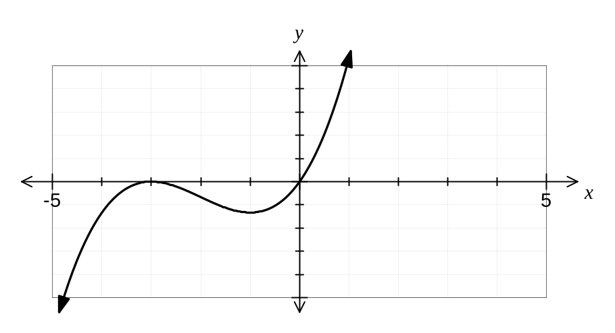

(d) Will 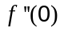 be negative, zero or positive? Justify your answer. (2 marks)
Positive.

Gradient of is clearly positive on the graph above.

Question 17 (8 marks)
An internet service provider plans to sample the volume of content downloaded per day by customers subscribing to their ADSL20 plan. From recent research, the company knew that the standard deviation of the volume of downloads per customer was 1.4 GB.

(a) Determine how large a sample the company should take in order to be 90% confident that the mean volume of downloads per customer calculated from their sample is within 0.25 GB of the true population mean. (2 marks)

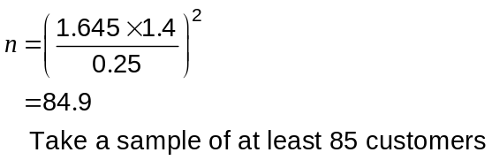

(b) A random selection of 25 subscribers was made and the total volume downloaded by these customers over a 24 hour period was 120GB. Calculate a 95% confidence interval for the mean volume of content downloaded per day by a customer. (4 marks)

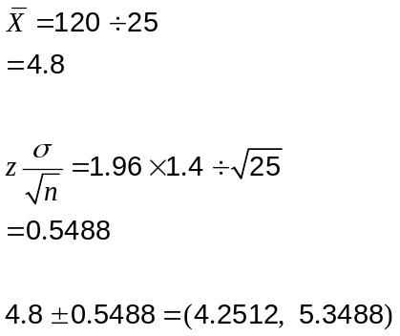

(c) If the company repeated the random sampling process and subsequent 95% confidence interval calculations from part (b) a total of 40 times, how many of the intervals calculated would you expect to contain the true population mean? Justify your answer. (2 marks)

38 of the intervals.

The 95% level of confidence refers to the 95% probability that the population mean is contained in the interval.

Question 18 (11 marks)
Anh and Botan run a part time business updating websites, working for at least 30 hours a week between them. Anh can complete two jobs in an hour and Botan can complete three jobs in an hour. Anh uses resources that cost $12 per hour while Botan uses resources that cost $10 per hour. They have decided to spend no more than $480 each week on resources and take on no more than 120 jobs.

Four of the boundaries representing these constraints (including 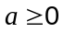 and 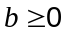) are shown on the graph below, where represents the weekly hours worked by Anh and the weekly hours worked by Botan.
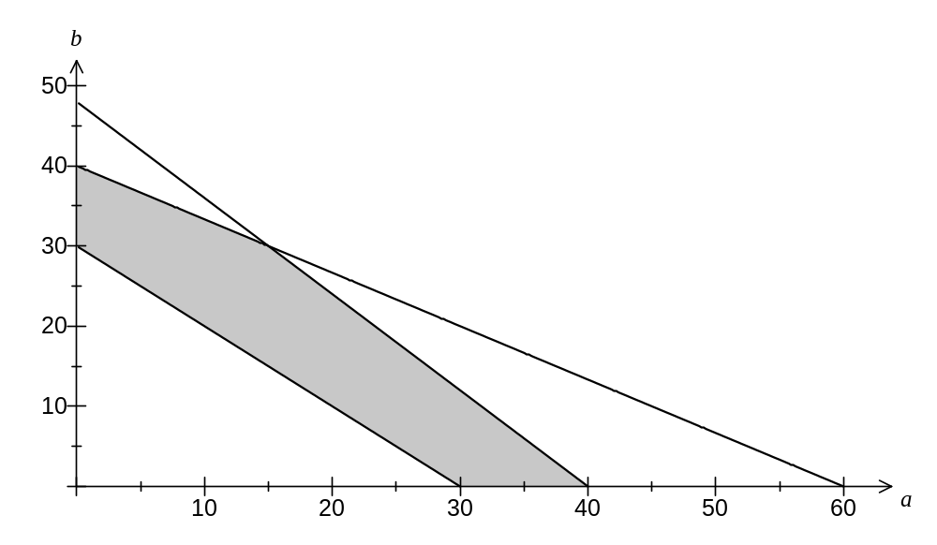
(a) Write down one more constraint, add it to the graph above and clearly indicate the feasible region for the number of hours worked each week by Anh and Botan. (3 marks)

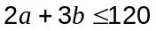

Anh and Botan make a profit of $24 and $30 respectively on each job they complete.

(b) Determine the hours that Anh and Botan should work to maximise their combined profit each week and state the maximum profit. Justify your answer. (4 marks)
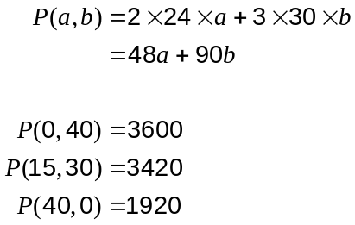

Anh should not work and Botan should work 40 hours.
Maximum profit would be $3600.

(c) One week Botan reduces the amount he charges and so his profit per job decreases. What would his profit per job have to drop below so that it would not be worth him working? (4 marks)

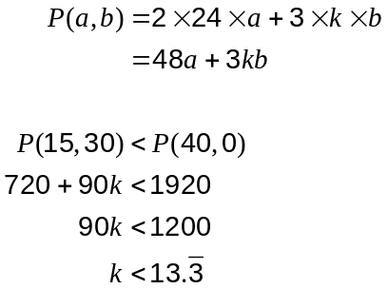

His profit per job would need to drop below $13.33 to the nearest cent.

Question 19 (10 marks)
The acceleration, ms⁻², of an object moving in a straight line for an interval of 30 seconds is shown in the graph below. When 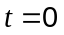, both the displacement, m and velocity, ms⁻¹ of the object are zero.
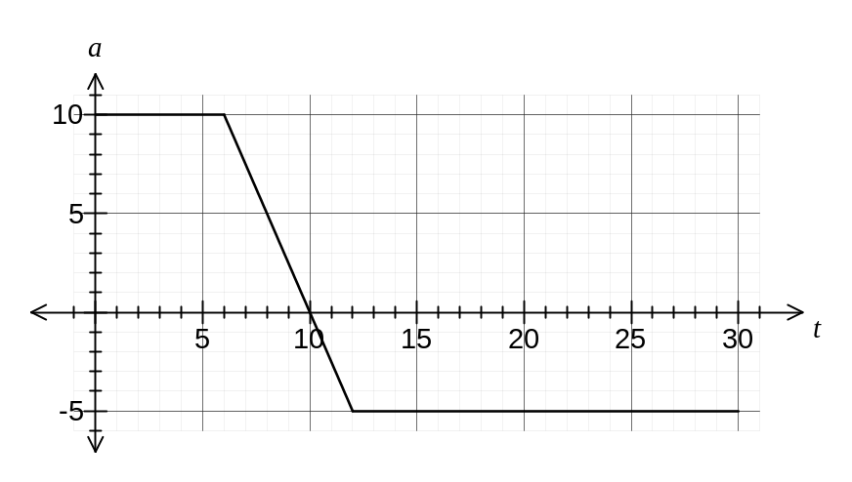
(a) Find the velocity of the object when 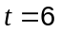 and when 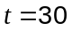. (3 marks)
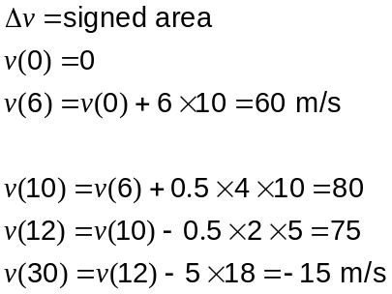

(b) Find the maximum velocity of the body. (1 mark)
Maximum velocity when 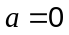

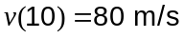

(c) Determine the displacement of the object when . (3 marks)
Between and 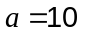.
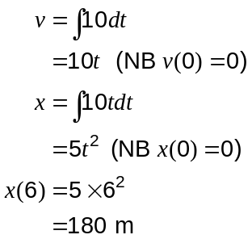

(d) Find the time at which the displacement of the object is a maximum. (3 marks)

Maximum displacement when 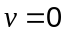

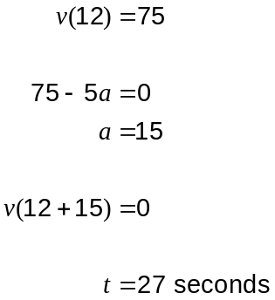

Question 20 (10 marks)
As part of a mathematics lesson, a teacher prepares some opaque cloth bags, each containing seven similar balls, three coloured red and four coloured blue.

A student randomly draws four balls from their bag, one after the other, without replacement.

(a) What is the probability they draw one red and three blue balls in any order? (2 marks)

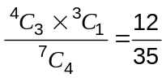

Let be the discrete random variable representing the total number of blue balls drawn in a random drawing of four balls from a bag, without replacement.

(b) Explain why is both a discrete and a random variable. (2 marks)
Discrete: Can only take the discrete values of 1, 2, 3 and 4.
Random: The balls are drawn in a random manner.

(c) Complete the graph below showing the probability distribution of . (3 marks)
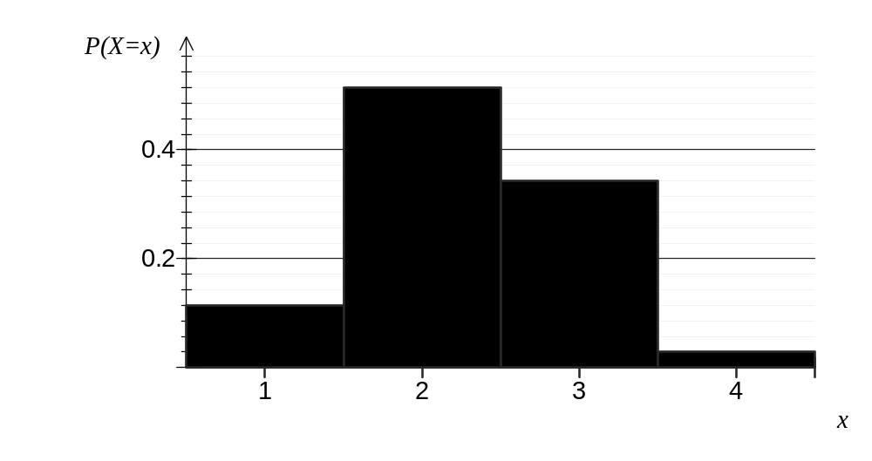
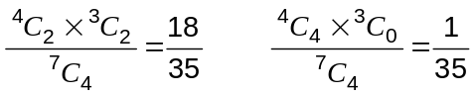

(d) All 22 students in the class draw four balls from their bags, without replacement. What is the probability that at least half of these students draw exactly one red ball? (3 marks)
Let be the number of students who draw exactly one red ball.

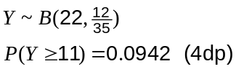

Question 21 (6 marks)
The three vertices of 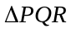 lie on a circle with centre 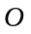.  Point lies on 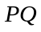 such that the lengths 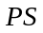 and 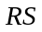 are equal and 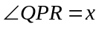. | 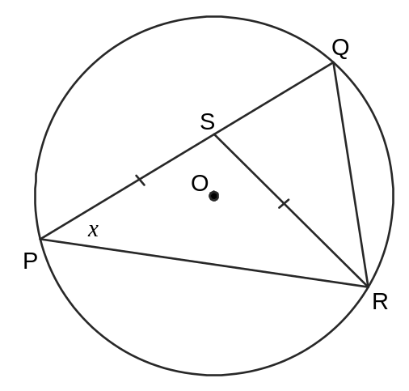
(a) Explain why 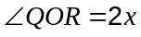. (1 mark)
The angle standing on a common chord (QR) at the centre of circle (QOR) is twice angle on circumference (QPR).

(b) Prove that 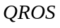 is a cyclic quadrilateral. (3 marks)
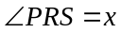 (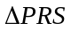 is isosceles).

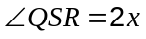 (external angle of triangle () is sum of opposite interior angles of triangle (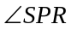 and 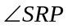)).

Note that 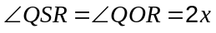.

Hence is a cyclic quadrilateral. (Angles standing on a common chord (QR) on the circumference of a circle are equal).

(c) Calculate the area of 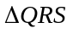 given the area of is 30 cm² and the ratio of lengths 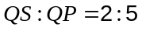. (2 marks)
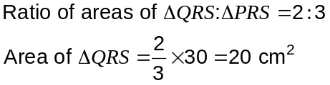

Additional working space

Question number: _________

Additional working space

Question number: _________

This examination paper may be freely copied, or communicated on an intranet, for non-commercial purposes within educational institutes that have purchased the paper from WA Examination Papers provided that WA Examination Papers is acknowledged as the copyright owner. Teachers within purchasing schools may change the paper provided that WA Examination Paper's moral rights are not infringed.

Copying or communication for any other purposes can only be done within the terms of the Copyright Act or with prior written permission of WA Examination papers.

Published by WA Examination Papers
PO Box 445 Claremont WA 6910

